# **Project 2 (Jenkins)**

## **Step 1:**

* Login to jenkins.
* From dashboard give name to project.
* Then select Freestyle project and click ok.

## **step 2:**

In Source code management select Git and add your repository link which contain java code.

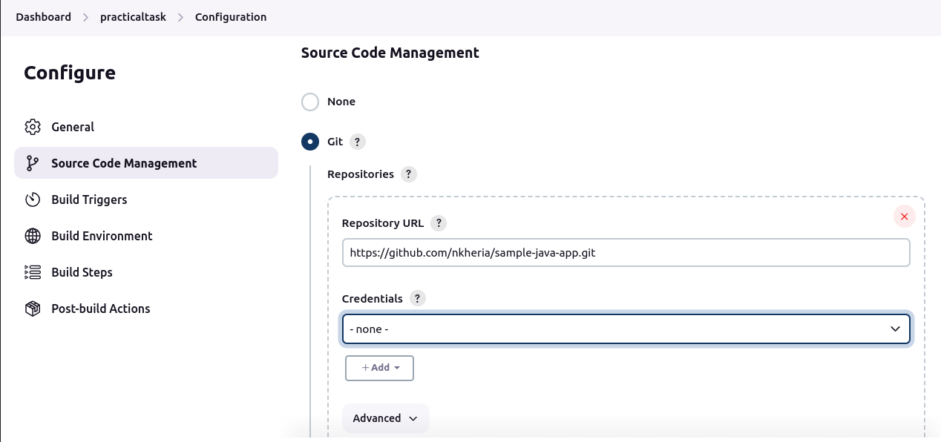

Make sure your repository is public if private then need to give credentials.

Select Branch name.

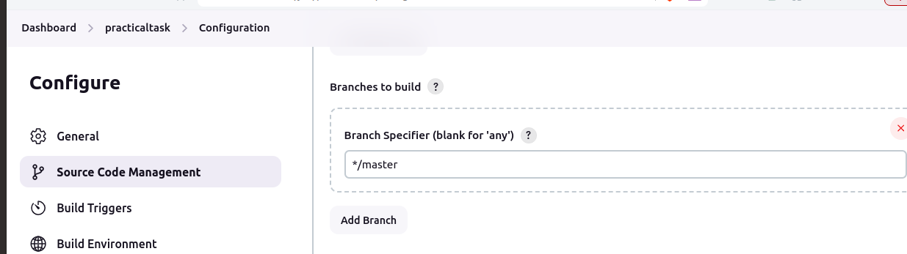

## **Step 3:**

* For periodically trigger pipeline we need to define period
* In Build Triggers select option Build periodically and add following line which trigger pipeline every 5 minutes.

*/5 * * * *

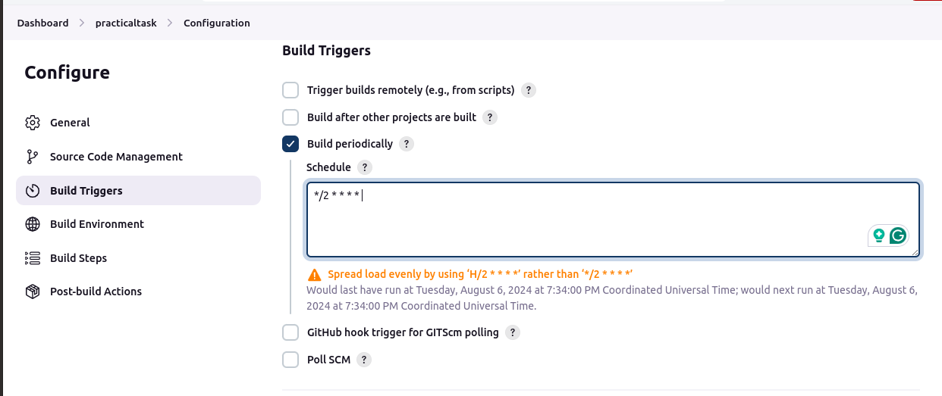

## **Step 4:**

* To run the java code we need to provide commands we provide that in Execute shell.
* For that In Build Steps select Execute shell and add commands in this case add following lines.

javac Sample.java

java Sample

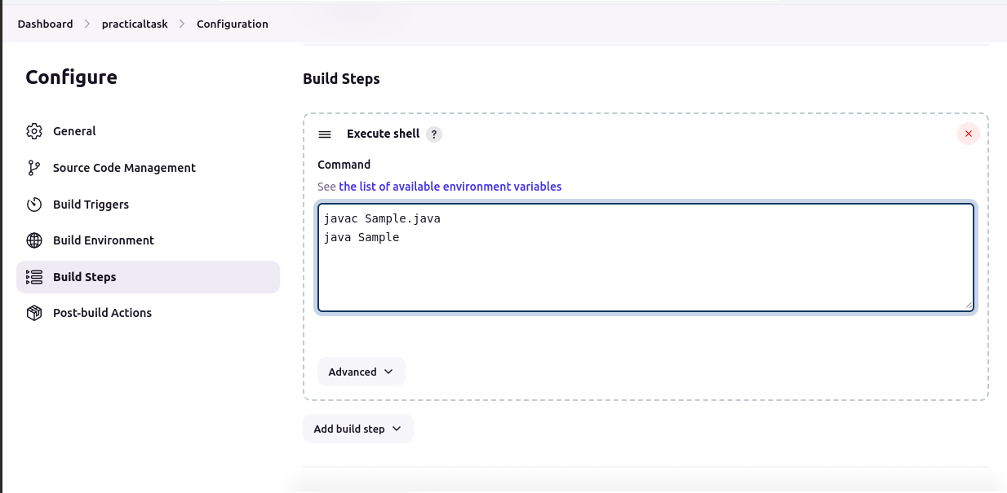

and click save.

## **Step 5:**

* To build project click on Build
* Then First build will create ,click on it.

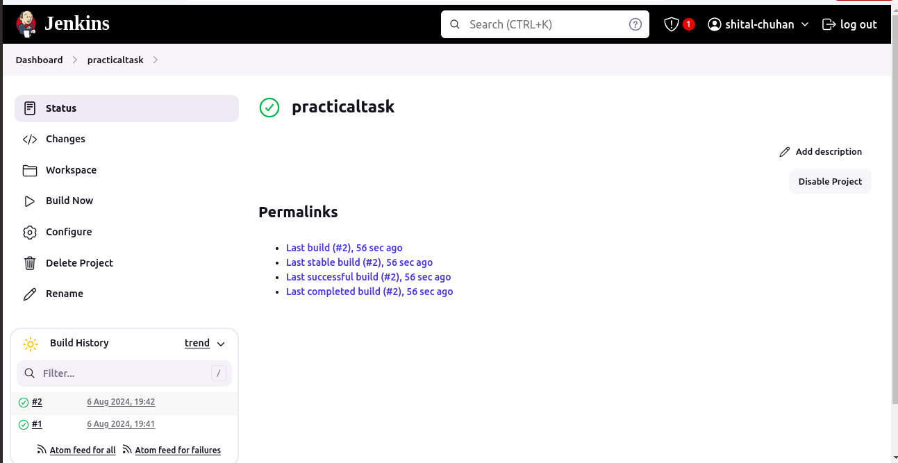

then click on Console output we can see the output of your java code.

